Upgrade to ACME screws
You may start upgrading you Piper 3d printer by installing ACME screws instead of 5/16 rods.

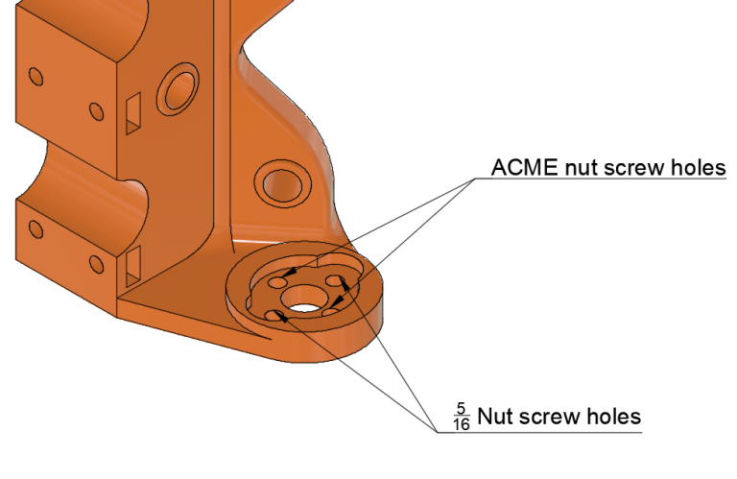
Upgrade to heated bed.
To upgrade to heated bed you may have several options. Those options depend on the size of the bed.

Bed size | Heating element wattage | Heat bed voltage | Example of parts | Notes
200mm x 200mm | 200+ W | 12 V is sufficient | Heated bed | you need a separate SSR as Ramps 1.4 does not provide enough current
200mm x 300mm | 300+ W | You may need a separate PSU or move to 24V PSU |  | may require changes to Ramps 1.4 board
300mm x 300mm | 450+ W | You need 110V(220V) heat panel, SSR DC to AC 25A and be very careful as moving pate will have wires with high voltage. |  | This is not recommended configuration since wires with high voltage will be constantly bended by moving bed, failure in wires may cause electrical shock.

